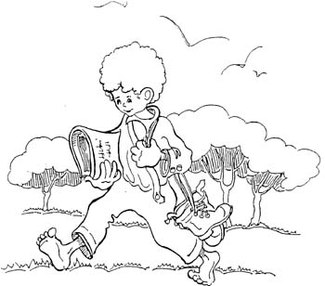

V. NEW FRONTIERS

Guideline 15: Main priority: poor young people.

Let each community.

- Face up to new forms of poverty experienced by the young in their locality, and keep alive a sensitivity to the most serious kinds.

- Express predilection for the poor by planning initiatives along with the educative and pastoral community which are explicitly dedicated to the poorest young people in the area.

- Feel particular solidarity with province works which are dedicated to the poorest.

- Seek responses to the spiritual forms of poverty of the young, offering them experiences and ways to re-awaken the religious dimension of life and help them discover Jesus as Saviour.

Guidelines 16: Other priorities: family social communication, Europe.

Let each community:

- Involve and form parents in the educative and evangelizing activity they carry out for their children.

- Develop curricula for affective education especially during adolescence and accompany young people during their time of engagement for marriage, making good use of the contribution of parents, lay people who share this responsibility and members of the Salesian Family.

- Foster new forms of evangelization and catechesis of families and by means of families.

- Plan educative projects to help young people to a critical and responsible use of various kinds of media [mass, folk, personal, convergent, etc] and encourage their active involvement in the social communication field and in youthful and popular forms of expression.

- Use the technologies of social communication to give greater visibility to their presence in order to spread the charism.



